Use Object Oriented Programming to Create a Stack

PART 1

First – Read about Structures and Classes

Structures are covered in the C++ for You++ book in chapter 13. Classes are found in chapter 15. As an alternate text, you might look at the the cplusplus.com online tutorial and read 3.5 Structures (http://cplusplus.com/doc/tutorial/structures.html) and 4.1 Classes , Constructors and Destructors. (http://cplusplus.com/doc/tutorial/classes.html)

What is a Stack
A stack is a basic Last In First Out (LIFO) memory structure. It is similar to storing books by piling them in a stack. To add (push) a book to a stack, you put it on top of the stack. To remove (pop) a book, the top book is taken from the stack. Books can only be added and removed in this way. In a computer program which emulates a stack, errors occur when you try to add (push) to a stack that has reached its maximum size (overflow), or when you try to take (pop) an item from an empty stack.

Building a stack
How does one actually build a stack? There are different ways to implement a stack, each with its own advantages and disadvantages. Here we will consider the simplest one: an array implementation.

Suppose, then, that you have a fixed-size array stack of, say, characters. In order to build a stack data structure from this array, we also need to define an integer ‘top’ which keeps track of the position of the top of the stack. For simplicity, suppose the array has size 5. Initially, top will have a value of -1, indicating that the stack is empty. As we push elements into the stack or pop elements from it, top will change accordingly, either increasing or decreasing. When top equals 4 (array size - 1), we know that the stack is full and no more pushes should be allowed.

Similarly, if we perform enough pops, top will reach -1 again, indicating that the stack is empty and we should not allow any more ‘pops’.

The actual operations push and pop can be defined as follows assuming top and stack are defined as shown:
int top = -1;
char stack[size];

void push ( char c )
{
top++;
stack [ top ] = c ;
}

char pop ( )
{
char c = stack [ top ] ;
top--;
return c ;
}

These functions should test for stack-empty and stack-full conditions but, for simplicity, we’ll ignore those tests here.

As an example, the figure below shows the result of applying the following sequence of
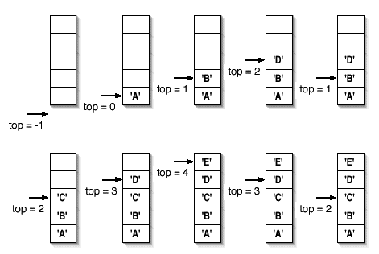
pushes and pops:

push ( ‘A’ ) ;
push ( ‘B’ ) ;
push ( ‘D’ ) ;
pop ( ) ;
push ( ‘C’ ) ;
push ( ‘D’ ) ;
push ( ‘E ’ ) ;
pop ( ) ;
pop ( ) ;

Note that popping the stack does not clear the array entry at the top of the stack prior
to popping it. Deleting that entry is never necessary and would be a waste of time, since
top keeps track of where the stack really ends.

Exercises
PART 1
- Write a Stack Class in C++. Use a fixed size array of 20 floats and a single integer variable to keep track of the size of the stack. The stack should be controlled by these member methods:
- Include a constructor which initializes the member variables.

- Member methods named “push” and “pop” that insert and return data from the stack. These should include error-checking.

PART 2 (After you learn about inheritance)
A) Create an inherited class which has additional method which add, subtract, multiply or divide the top two elements of the stack and replace them with the result. Each of these four functions should call the push and pop methods defined earlier. Each time one of these operations is executed, the size of the stack should drop by one. Also, include a ‘display’ function which returns the value from the top of the stack without removing it from the stack.

B) Use this class to make a simulated RPN calculator. If you do not know what a RPN calculator is, each of these sites has a Java Applet that you can try. Your RPN calculator simulator should show the top two items in the stack.
- http://webonastick.com/rpncalc/ (I want your program to work similar to this.)
- http://www.paludavia.com/hp35/ (This is the original HP RPN calculator)

PART 3 (After you learn about header files)
- In order to make your code easier to read, it is a good idea to store class definitions in a header file and class methods in another .cpp file. The Header file should end with a '.h' and it should begin with "IF_DEF" statemement. (Find our what this statement does.) The header file should only include the class definition and #include all of the member methods definitions. When this is done, the primary program file will only contain the 'main' function and a few other supporting functions. If the class and its methods are well named, a person will be able to read the code without understanding how the class works in detail.

PART 4 (After you learn about linked lists)
A) Change the basic 'stack' class in your program to make it dynamic. It should store all values in a linked list instead of a fixed size array. You may also need to change your display function. Your linked list should use the identifiers 'head' 'node' 'temp' and 'newnode' as appropriate.

